Reconnaissance Report —aliasghargroup.com
Author: Amina malik
Date: 19 September 2025
Scope / Target: aliasghargroup.com

1. What is Reconnaissance?
Reconnaissance (recon) is the information-gathering stage of a security assessment. Its goal is to build an accurate picture of a target’s public footprint — domains, IP addresses, hosting, services, and related infrastructure — so later testing is focused and safe. Recon is typically non-destructive and can be split into passive (no direct interaction with the target) and active (direct queries or probes against the target).

2. Types of Recon
- Passive Reconnaissance: Collecting information from public sources (DNS records, certificate logs, search engines, passive DNS datasets, public WHOIS records) without sending traffic directly to the target’s hosts. Lower risk and less likely to alert defenders.
- Active Reconnaissance: Direct interaction with the target (ping, port scans, web requests, directory discovery). Provides confirmation that services are live and reveals runtime behaviour. Requires authorization before running against non-owned targets.

3. Objective of this Report
- Summarize the public footprint of aliasghargroup.com.
- Separate findings from passive and active techniques.
- Provide context for potential follow-up testing (with permission).
- Present evidence (screenshots or copied output) for validation.

4. Methodology
- Passive first: Query WHOIS, DNS, certificate transparency logs, and OSINT sources to gather domain age, ownership metadata, name servers, MX/TXT records, and candidate subdomains. Tools: whois, dig, nslookup, crt.sh (via curl), theHarvester, subfinder, amass.
- Triage: Deduplicate results, resolve discovered names to IPs, and identify live hosts.
- Active validation (with caution): Use ping, curl for headers and HTTP checks, and targeted nmap scans for specific ports (80/443). Avoid aggressive scans behind CDNs or without permission.
All commands used during this engagement were executed interactively in a terminal (no persistent files saved per the tester's constraint). Commands used are available on request.

5. Tools Used
- Passive: whois, dig, nslookup, crt.sh (via curl), theHarvester, subfinder, amass.
- Active: ping, curl, nmap (targeted), whatweb (optional), openssl s_client (for certs).

6. Passive Recon Findings
- WHOIS:
  - Registrar: DreamHost, LLC
  - Creation Date: 2025-08-27 (recently registered)
  - Registrant: Privacy/Proxy (Proxy Protection LLC) — contact masked by registrar
  - Name Servers: ns1.stackdns.com, ns2.stackdns.com, ns3.stackdns.com, ns4.stackdns.com
  - DNSSEC: unsigned
Interpretation: A very new domain with privacy protection enabled. New domains are common for fresh projects but also for malicious/abusive use; treat as a contextual flag rather than proof of malicious intent.
- DNS records (dig queries):
  - A: 185.151.30.186
  - AAAA: 2a07:7800::186
  - MX: mx.stackmail.com (priority 10)
  - TXT: google-site-verification=... and v=spf1 include:spf.stackmail.com a mx -all (indicates mail is managed via stackmail / SPF configured)
  - NS: StackDNS name servers (managed DNS / CDN)
- Certificate Transparency / Subdomains:
  - crt.sh and passive enumeration returned entries indicating aliasghargroup.com and wildcard *.aliasghargroup.com – suggests certificates exist for the domain and possibly multiple subdomains.
- OSINT / Email harvesting:
  - theHarvester discovered info@aliasghargroup.com (publicly exposed contact).
- Subdomain enumeration (passive):
  - subfinder / amass found: aliasghargroup.com, www.aliasghargroup.com (no extensive list of legacy subdomains discovered).

7. Active Recon Findings
Note: Basic, non-destructive active checks only (HTTP headers, ping, and targeted nmap). No aggressive scanning was performed and all commands were controlled to avoid excessive traffic.
- Host reachability:
  - ping -c 4 aliasghargroup.com → 185.151.30.186 responded (avg RTT 134 ms) — host is reachable via ICMP.
- HTTP headers / web stack:
  - curl -I https://aliasghargroup.com returned HTTP/2 200 and headers showing:
    - Server: Apache
    - X-Powered-By: PHP/8.2.29
    - Link: <.../wp-json/> → indicates WordPress REST API present
    - Caching headers and X-Provided-By: StackCDN → site served behind StackCDN
Interpretation: A WordPress site hosted behind a CDN. The presence of wp-json and standard WordPress headers suggests a typical WP install.
- Port scanning (targeted):
  - nmap -sV -p1-1024 aliasghargroup.com detected:
    - 80/tcp – open (tcpwrapped)
    - 443/tcp – open (tcpwrapped)
  - nmap -sS -p- --min-rate=1000 returned all ports filtered (likely due to CDN/firewall/protections)
Interpretation: Only standard HTTP(S) ports are publicly reachable; other ports are filtered. Nmap reports tcpwrapped due to a proxy/CDN that limits fingerprinting.

8. Evidence / Screenshots
Paste screenshots below (or paste clipboard images into your report). If you captured terminal output instead of screenshots, paste the blocks here.
- Screenshot 1 – WHOIS output 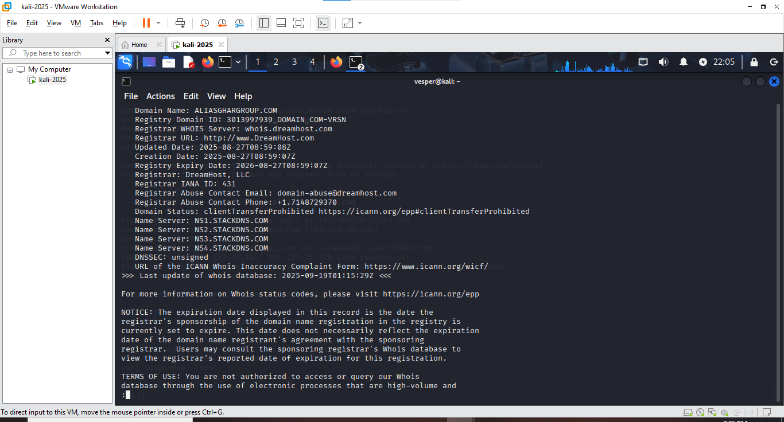
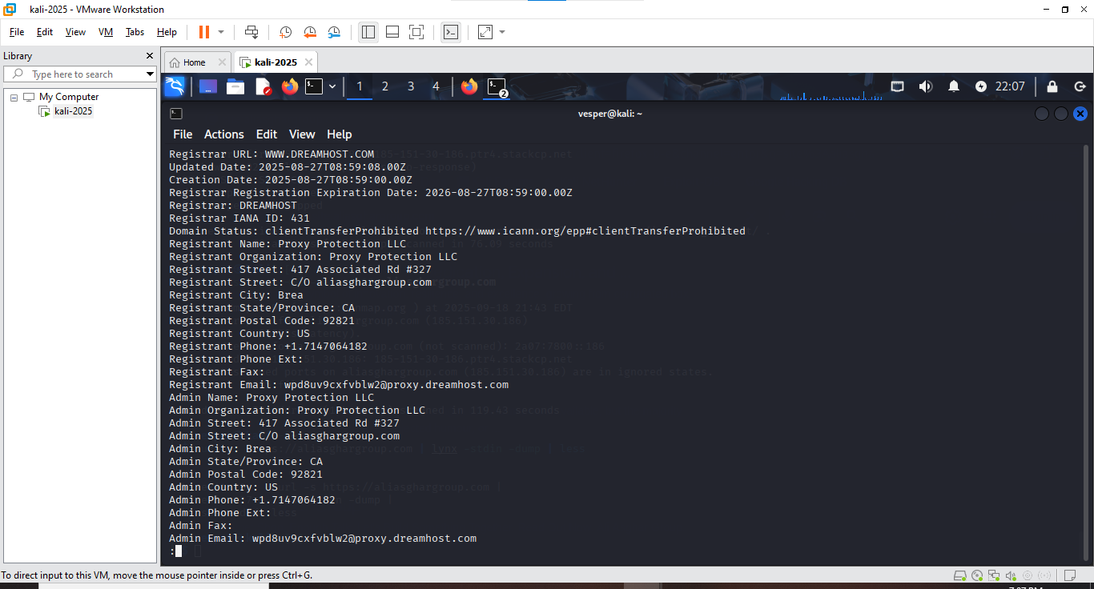
- Screenshot 2 – dig output showing A/AAAA/NS/MX/TXT 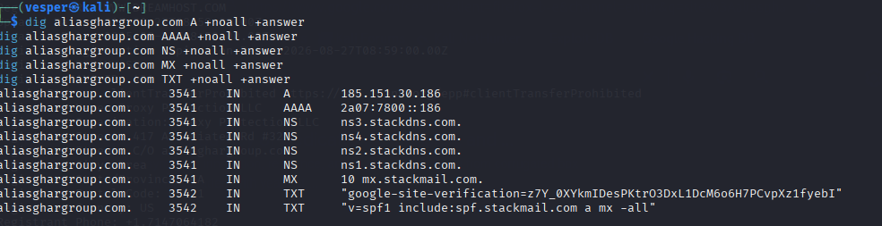
- Screenshot 3 – curl -I headers showing WordPress and StackCDN 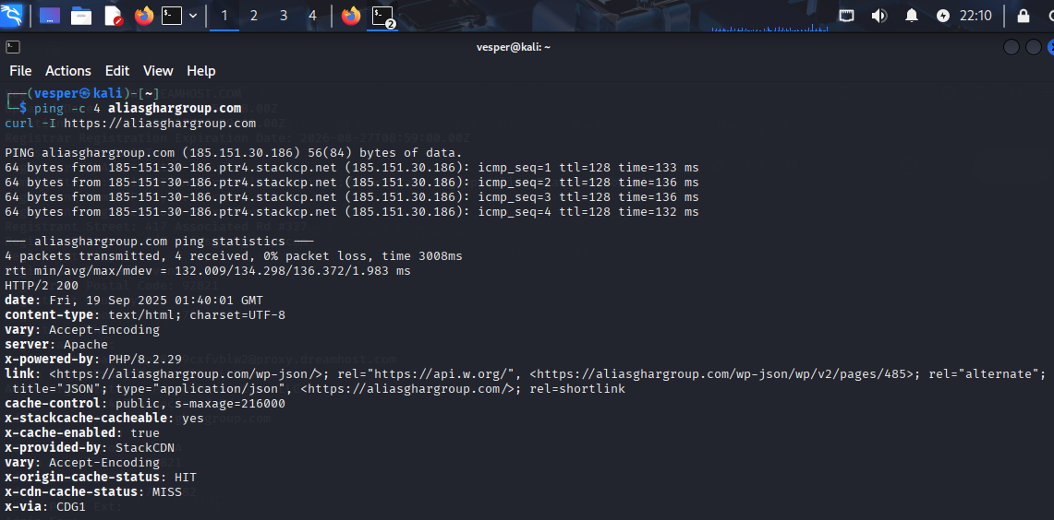
- Screenshot 4 – subfinder / theHarvester output 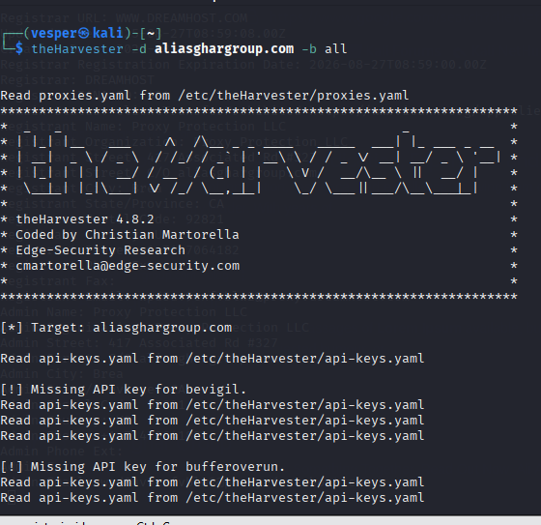
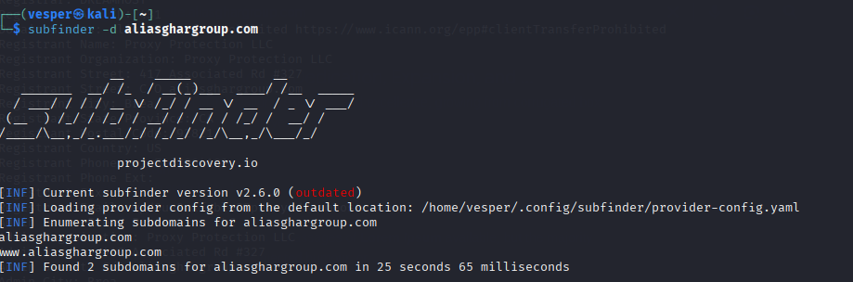

9. Recommendations & Next Steps
- If authorized to continue testing:
  - Perform an authenticated WordPress enumeration (identify plugins/themes versions) in a controlled manner.
  - Check for exposed sensitive files (readme.html, .git, backup files) using a small, targeted directory scan and only with permission.
  - Inspect TLS certificate details for SANs to find additional hostnames.
- If not authorized:
  - Limit activity to passive monitoring and public OSINT. Report findings to the owner if appropriate.
- Operational note:
  - CDNs and provider firewalls are masking origin details — obtaining the origin IP may require collaborating with the hosting provider or owner (with legal authorization).

10. Conclusion (human, professional)
This reconnaissance engagement found that aliasghargroup.com is a recently registered domain (Aug 27, 2025) using DreamHost for registration and StackDNS/StackCDN for DNS and content delivery. The site appears to be a WordPress site served over HTTPS (PHP 8.2) with an MX record pointing to mx.stackmail.com and SPF configured for stackmail. Passive OSINT revealed a contact email (info@aliasghargroup.com) and certificate entries indicating the domain and wildcard usage.
Active checks confirmed the site is reachable and responds on HTTP/HTTPS only; other TCP ports are filtered — consistent with CDN/firewall protection. Given the domain's recency and privacy-protected WHOIS, further investigation (plugin/theme scans, origin discovery) should only proceed with written authorization.

